**1 to 1 Flow**

Flow 1 (10.1.1.1 -> 10.1.1.2)

Tx Packets = 1098

Rx Packets = 1098

Tx Bytes: 592920

Rx Bytes: 592920

Throughput: 0.503049 Mbps

Lost Packets= 0

Delay Sum= +6380519708.0ns

Jitter Sum= +14411656.0ns

**2 to 1 Flow**

Flow 1 (10.1.1.2 -> 10.1.1.1)

Tx Packets = 1098

Rx Packets = 776

Tx Bytes: 592920

Rx Bytes: 419040

Throughput: 0.344607 Mbps

Lost Packets= 476

Delay Sum= +238570801832.0ns

Jitter Sum= +2865582116.0ns

Flow 2 (10.1.1.3 -> 10.1.1.2)

Tx Packets = 1098

Rx Packets = 1098

Tx Bytes: 592920

Rx Bytes: 592920

Throughput: 0.502615 Mbps

Lost Packets= 0

Delay Sum= +12405258518.0ns

Jitter Sum= +3764062656.0ns

**3 to 1 Flow**

Flow 1 (10.1.1.2 -> 10.1.1.1)

Tx Packets = 1098

Rx Packets = 1098

Tx Bytes: 592920

Rx Bytes: 592920

Throughput: 0.502889 Mbps

Lost Packets= 0

Delay Sum= +13844230523.0ns

Jitter Sum= +2546267918.0ns

Flow 2 (10.1.1.3 -> 10.1.1.2)

Tx Packets = 1098

Rx Packets = 651

Tx Bytes: 592920

Rx Bytes: 351540

Throughput: 0.268612 Mbps

Lost Packets= 739

Delay Sum= +410021717446.0ns

Jitter Sum= +3359803915.0ns

Flow 3 (10.1.1.4 -> 10.1.1.3)

Tx Packets = 1098

Rx Packets = 937

Tx Bytes: 592920

Rx Bytes: 505980

Throughput: 0.405292 Mbps

Lost Packets= 0

Delay Sum= +448560171134.0ns

Jitter Sum= +4874948933.0ns

**4 to 1 Flow**

Flow 1 (10.1.1.2 -> 10.1.1.1)

Tx Packets = 1098

Rx Packets = 1097

Tx Bytes: 592920

Rx Bytes: 592380

Throughput: 0.502583 Mbps

Lost Packets= 0

Delay Sum= +25756824776.0ns

Jitter Sum= +2829091720.0ns

Flow 2 (10.1.1.3 -> 10.1.1.2)

Tx Packets = 1098

Rx Packets = 736

Tx Bytes: 592920

Rx Bytes: 397440

Throughput: 0.304404 Mbps

Lost Packets= 579

Delay Sum= +365916275454.0ns

Jitter Sum= +3882889816.0ns

Flow 3 (10.1.1.4 -> 10.1.1.3)

Tx Packets = 1098

Rx Packets = 470

Tx Bytes: 592920

Rx Bytes: 253800

Throughput: 0.193976 Mbps

Lost Packets= 900

Delay Sum= +507763990507.0ns

Jitter Sum= +3746590149.0ns

Flow 4 (10.1.1.5 -> 10.1.1.4)

Tx Packets = 1098

Rx Packets = 1058

Tx Bytes: 592920

Rx Bytes: 571320

Throughput: 0.457493 Mbps

Lost Packets= 0

Delay Sum= +404794260297.0ns

Jitter Sum= +4765853519.0ns

**5 to 1 Flow**

Flow 1 (10.1.1.2 -> 10.1.1.1)

Tx Packets = 1098

Rx Packets = 1098

Tx Bytes: 592920

Rx Bytes: 592920

Throughput: 0.502693 Mbps

Lost Packets= 0

Delay Sum= +18935360664.0ns

Jitter Sum= +2508633716.0ns

Flow 2 (10.1.1.3 -> 10.1.1.2)

Tx Packets = 1098

Rx Packets = 656

Tx Bytes: 592920

Rx Bytes: 354240

Throughput: 0.270872 Mbps

Lost Packets= 703

Delay Sum= +403714317657.0ns

Jitter Sum= +3558098083.0ns

Flow 3 (10.1.1.4 -> 10.1.1.3)

Tx Packets = 1098

Rx Packets = 673

Tx Bytes: 592920

Rx Bytes: 363420

Throughput: 0.27789 Mbps

Lost Packets= 653

Delay Sum= +587210847604.0ns

Jitter Sum= +4200695103.0ns

Flow 4 (10.1.1.5 -> 10.1.1.4)

Tx Packets = 1098

Rx Packets = 527

Tx Bytes: 592920

Rx Bytes: 284580

Throughput: 0.217853 Mbps

Lost Packets= 919

Delay Sum= +446708827261.0ns

Jitter Sum= +3788768702.0ns

Flow 5 (10.1.1.6 -> 10.1.1.5)

Tx Packets = 1098

Rx Packets = 1028

Tx Bytes: 592920

Rx Bytes: 555120

Throughput: 0.442214 Mbps

Lost Packets= 0

Delay Sum= +449288919354.0ns

Jitter Sum= +4783205174.0ns

**6 to 1 Flow**

Flow 1 (10.1.1.2 -> 10.1.1.1)

Tx Packets = 1098

Rx Packets = 1098

Tx Bytes: 592920

Rx Bytes: 592920

Throughput: 0.503049 Mbps

Lost Packets= 0

Delay Sum= +26065090015.0ns

Jitter Sum= +2816081844.0ns

Flow 2 (10.1.1.3 -> 10.1.1.2)

Tx Packets = 1098

Rx Packets = 650

Tx Bytes: 592920

Rx Bytes: 351000

Throughput: 0.268202 Mbps

Lost Packets= 763

Delay Sum= +355995217747.0ns

Jitter Sum= +3535891592.0ns

Flow 3 (10.1.1.4 -> 10.1.1.3)

Tx Packets = 1098

Rx Packets = 572

Tx Bytes: 592920

Rx Bytes: 308880

Throughput: 0.236015 Mbps

Lost Packets= 776

Delay Sum= +534875833220.0ns

Jitter Sum= +3866428945.0ns

Flow 4 (10.1.1.5 -> 10.1.1.4)

Tx Packets = 1098

Rx Packets = 615

Tx Bytes: 592920

Rx Bytes: 332100

Throughput: 0.253656 Mbps

Lost Packets= 775

Delay Sum= +452193327926.0ns

Jitter Sum= +3900067767.0ns

Flow 5 (10.1.1.6 -> 10.1.1.5)

Tx Packets = 1098

Rx Packets = 607

Tx Bytes: 592920

Rx Bytes: 327780

Throughput: 0.250741 Mbps

Lost Packets= 733

Delay Sum= +458094227664.0ns

Jitter Sum= +3783611786.0ns

Flow 6 (10.1.1.7 -> 10.1.1.6)

Tx Packets = 1098

Rx Packets = 1025

Tx Bytes: 592920

Rx Bytes: 553500

Throughput: 0.446206 Mbps

Lost Packets= 0

Delay Sum= +450051847476.0ns

Jitter Sum= +4862753543.0ns

**7 to 1 Flow**

Flow 1 (10.1.1.2 -> 10.1.1.1)

Tx Packets = 1098

Rx Packets = 1097

Tx Bytes: 592920

Rx Bytes: 592380

Throughput: 0.499802 Mbps

Lost Packets= 0

Delay Sum= +37047917872.0ns

Jitter Sum= +3340983054.0ns

Flow 2 (10.1.1.3 -> 10.1.1.2)

Tx Packets = 1098

Rx Packets = 713

Tx Bytes: 592920

Rx Bytes: 385020

Throughput: 0.294976 Mbps

Lost Packets= 668

Delay Sum= +348738171085.0ns

Jitter Sum= +3693947669.0ns

Flow 3 (10.1.1.4 -> 10.1.1.3)

Tx Packets = 1098

Rx Packets = 523

Tx Bytes: 592920

Rx Bytes: 282420

Throughput: 0.215894 Mbps

Lost Packets= 857

Delay Sum= +464918191008.0ns

Jitter Sum= +4211789637.0ns

Flow 4 (10.1.1.5 -> 10.1.1.4)

Tx Packets = 1098

Rx Packets = 597

Tx Bytes: 592920

Rx Bytes: 322380

Throughput: 0.246449 Mbps

Lost Packets= 818

Delay Sum= +435765157296.0ns

Jitter Sum= +3805109176.0ns

Flow 5 (10.1.1.6 -> 10.1.1.5)

Tx Packets = 1098

Rx Packets = 631

Tx Bytes: 592920

Rx Bytes: 340740

Throughput: 0.260254 Mbps

Lost Packets= 757

Delay Sum= +442064637025.0ns

Jitter Sum= +4011868871.0ns

Flow 6 (10.1.1.7 -> 10.1.1.6)

Tx Packets = 1098

Rx Packets = 510

Tx Bytes: 592920

Rx Bytes: 275400

Throughput: 0.210331 Mbps

Lost Packets= 885

Delay Sum= +442012959000.0ns

Jitter Sum= +3760380024.0ns

Flow 7 (10.1.1.8 -> 10.1.1.7)

Tx Packets = 1098

Rx Packets = 1059

Tx Bytes: 592920

Rx Bytes: 571860

Throughput: 0.460131 Mbps

Lost Packets= 0

Delay Sum= +441750839189.0ns

Jitter Sum= +4660638176.0ns

**8 to 1 Flow**

Flow 1 (10.1.1.2 -> 10.1.1.1)

Tx Packets = 1098

Rx Packets = 1097

Tx Bytes: 592920

Rx Bytes: 592380

Throughput: 0.50132 Mbps

Lost Packets= 0

Delay Sum= +38243228150.0ns

Jitter Sum= +3360622130.0ns

Flow 2 (10.1.1.3 -> 10.1.1.2)

Tx Packets = 1098

Rx Packets = 732

Tx Bytes: 592920

Rx Bytes: 395280

Throughput: 0.30288 Mbps

Lost Packets= 630

Delay Sum= +295398850895.0ns

Jitter Sum= +3825427746.0ns

Flow 3 (10.1.1.4 -> 10.1.1.3)

Tx Packets = 1098

Rx Packets = 480

Tx Bytes: 592920

Rx Bytes: 259200

Throughput: 0.198145 Mbps

Lost Packets= 904

Delay Sum= +519256515244.0ns

Jitter Sum= +3871508393.0ns

Flow 4 (10.1.1.5 -> 10.1.1.4)

Tx Packets = 1098

Rx Packets = 636

Tx Bytes: 592920

Rx Bytes: 343440

Throughput: 0.262315 Mbps

Lost Packets= 782

Delay Sum= +347746638030.0ns

Jitter Sum= +3806836347.0ns

Flow 5 (10.1.1.6 -> 10.1.1.5)

Tx Packets = 1098

Rx Packets = 513

Tx Bytes: 592920

Rx Bytes: 277020

Throughput: 0.212374 Mbps

Lost Packets= 904

Delay Sum= +467825111520.0ns

Jitter Sum= +3751402497.0ns

Flow 6 (10.1.1.7 -> 10.1.1.6)

Tx Packets = 1098

Rx Packets = 706

Tx Bytes: 592920

Rx Bytes: 381240

Throughput: 0.291309 Mbps

Lost Packets= 658

Delay Sum= +439222460475.0ns

Jitter Sum= +4032929298.0ns

Flow 7 (10.1.1.8 -> 10.1.1.7)

Tx Packets = 1098

Rx Packets = 468

Tx Bytes: 592920

Rx Bytes: 252720

Throughput: 0.193042 Mbps

Lost Packets= 898

Delay Sum= +468563181336.0ns

Jitter Sum= +3767598210.0ns

Flow 8 (10.1.1.9 -> 10.1.1.8)

Tx Packets = 1098

Rx Packets = 1074

Tx Bytes: 592920

Rx Bytes: 579960

Throughput: 0.465729 Mbps

Lost Packets= 0

Delay Sum= +415175622092.0ns

Jitter Sum= +4545551777.0ns

**9 to 1 Flow**

Flow 1 (10.1.1.2 -> 10.1.1.1)

Tx Packets = 1098

Rx Packets = 1097

Tx Bytes: 592920

Rx Bytes: 592380

Throughput: 0.493751 Mbps

Lost Packets= 0

Delay Sum= +50548737621.0ns

Jitter Sum= +3281351143.0ns

Flow 2 (10.1.1.3 -> 10.1.1.2)

Tx Packets = 1098

Rx Packets = 668

Tx Bytes: 592920

Rx Bytes: 360720

Throughput: 0.276359 Mbps

Lost Packets= 726

Delay Sum= +351328602565.0ns

Jitter Sum= +3539363691.0ns

Flow 3 (10.1.1.4 -> 10.1.1.3)

Tx Packets = 1098

Rx Packets = 528

Tx Bytes: 592920

Rx Bytes: 285120

Throughput: 0.217797 Mbps

Lost Packets= 843

Delay Sum= +487501680425.0ns

Jitter Sum= +3876169089.0ns

Flow 4 (10.1.1.5 -> 10.1.1.4)

Tx Packets = 1098

Rx Packets = 587

Tx Bytes: 592920

Rx Bytes: 316980

Throughput: 0.242115 Mbps

Lost Packets= 794

Delay Sum= +406175767059.0ns

Jitter Sum= +3930072929.0ns

Flow 5 (10.1.1.6 -> 10.1.1.5)

Tx Packets = 1098

Rx Packets = 716

Tx Bytes: 592920

Rx Bytes: 386640

Throughput: 0.295367 Mbps

Lost Packets= 630

Delay Sum= +505890639651.0ns

Jitter Sum= +4193500954.0ns

Flow 6 (10.1.1.7 -> 10.1.1.6)

Tx Packets = 1098

Rx Packets = 485

Tx Bytes: 592920

Rx Bytes: 261900

Throughput: 0.200084 Mbps

Lost Packets= 970

Delay Sum= +467315440443.0ns

Jitter Sum= +3583335148.0ns

Flow 7 (10.1.1.8 -> 10.1.1.7)

Tx Packets = 1098

Rx Packets = 774

Tx Bytes: 592920

Rx Bytes: 417960

Throughput: 0.319949 Mbps

Lost Packets= 503

Delay Sum= +440551416940.0ns

Jitter Sum= +4518931987.0ns

Flow 8 (10.1.1.9 -> 10.1.1.8)

Tx Packets = 1098

Rx Packets = 449

Tx Bytes: 592920

Rx Bytes: 242460

Throughput: 0.185189 Mbps

Lost Packets= 982

Delay Sum= +527527446347.0ns

Jitter Sum= +3918520499.0ns

Flow 9 (10.1.1.10 -> 10.1.1.9)

Tx Packets = 1098

Rx Packets = 1064

Tx Bytes: 592920

Rx Bytes: 574560

Throughput: 0.461009 Mbps

Lost Packets= 0

Delay Sum= +323532284081.0ns

Jitter Sum= +4604235021.0ns

**10 to 1 Flow**

Flow 1 (10.1.1.2 -> 10.1.1.1)

Tx Packets = 1098

Rx Packets = 1097

Tx Bytes: 592920

Rx Bytes: 592380

Throughput: 0.502287 Mbps

Lost Packets= 0

Delay Sum= +23269679913.0ns

Jitter Sum= +3141757881.0ns

Flow 2 (10.1.1.3 -> 10.1.1.2)

Tx Packets = 1098

Rx Packets = 706

Tx Bytes: 592920

Rx Bytes: 381240

Throughput: 0.291162 Mbps

Lost Packets= 649

Delay Sum= +344022870224.0ns

Jitter Sum= +3995854027.0ns

Flow 3 (10.1.1.4 -> 10.1.1.3)

Tx Packets = 1098

Rx Packets = 503

Tx Bytes: 592920

Rx Bytes: 271620

Throughput: 0.207843 Mbps

Lost Packets= 869

Delay Sum= +556807430338.0ns

Jitter Sum= +4020267026.0ns

Flow 4 (10.1.1.5 -> 10.1.1.4)

Tx Packets = 1098

Rx Packets = 716

Tx Bytes: 592920

Rx Bytes: 386640

Throughput: 0.295334 Mbps

Lost Packets= 638

Delay Sum= +369703409050.0ns

Jitter Sum= +3990123925.0ns

Flow 5 (10.1.1.6 -> 10.1.1.5)

Tx Packets = 1098

Rx Packets = 501

Tx Bytes: 592920

Rx Bytes: 270540

Throughput: 0.206881 Mbps

Lost Packets= 932

Delay Sum= +460773349921.0ns

Jitter Sum= +3604628288.0ns

Flow 6 (10.1.1.7 -> 10.1.1.6)

Tx Packets = 1098

Rx Packets = 654

Tx Bytes: 592920

Rx Bytes: 353160

Throughput: 0.26977 Mbps

Lost Packets= 708

Delay Sum= +395325356669.0ns

Jitter Sum= +3828831178.0ns

Flow 7 (10.1.1.8 -> 10.1.1.7)

Tx Packets = 1098

Rx Packets = 565

Tx Bytes: 592920

Rx Bytes: 305100

Throughput: 0.232979 Mbps

Lost Packets= 857

Delay Sum= +472706219596.0ns

Jitter Sum= +3823531820.0ns

Flow 8 (10.1.1.9 -> 10.1.1.8)

Tx Packets = 1098

Rx Packets = 659

Tx Bytes: 592920

Rx Bytes: 355860

Throughput: 0.272111 Mbps

Lost Packets= 721

Delay Sum= +420731594995.0ns

Jitter Sum= +3948072359.0ns

Flow 9 (10.1.1.10 -> 10.1.1.9)

Tx Packets = 1098

Rx Packets = 553

Tx Bytes: 592920

Rx Bytes: 298620

Throughput: 0.228312 Mbps

Lost Packets= 824

Delay Sum= +502757251384.0ns

Jitter Sum= +3896236368.0ns

Flow 10 (10.1.1.11 -> 10.1.1.10)

Tx Packets = 1098

Rx Packets = 1036

Tx Bytes: 592920

Rx Bytes: 559440

Throughput: 0.446024 Mbps

Lost Packets= 0

Delay Sum= +457193705858.0ns

Jitter Sum= +4956752333.0ns

**1 to 1 Flow**

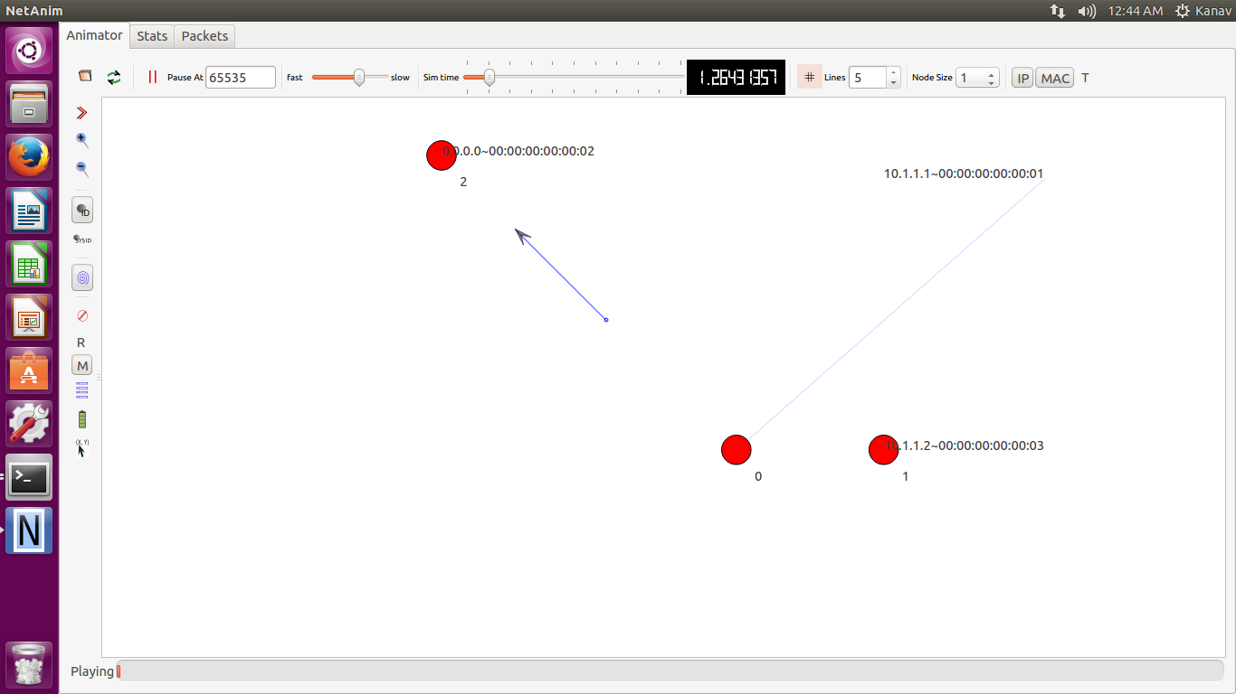

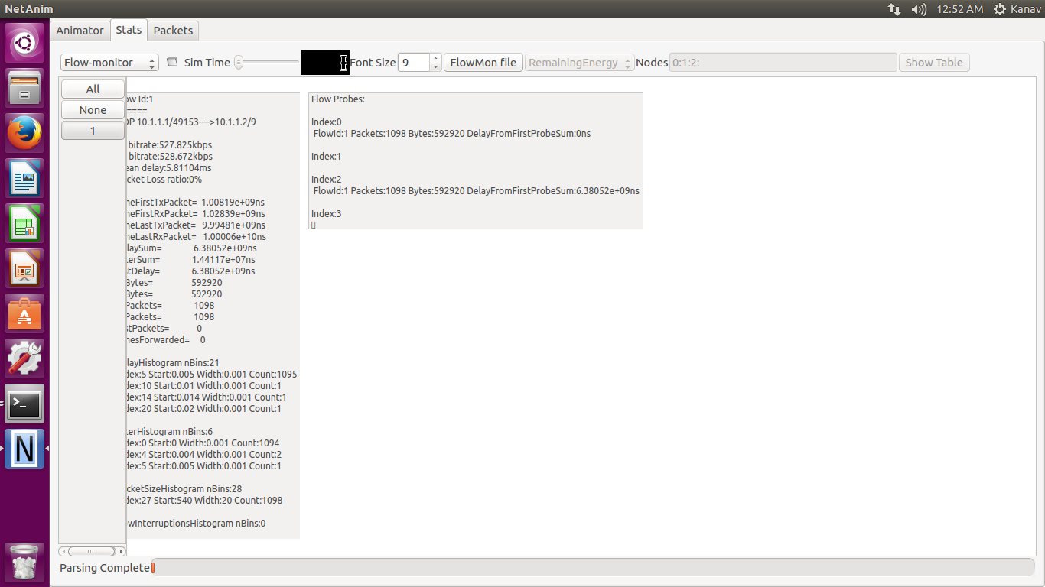

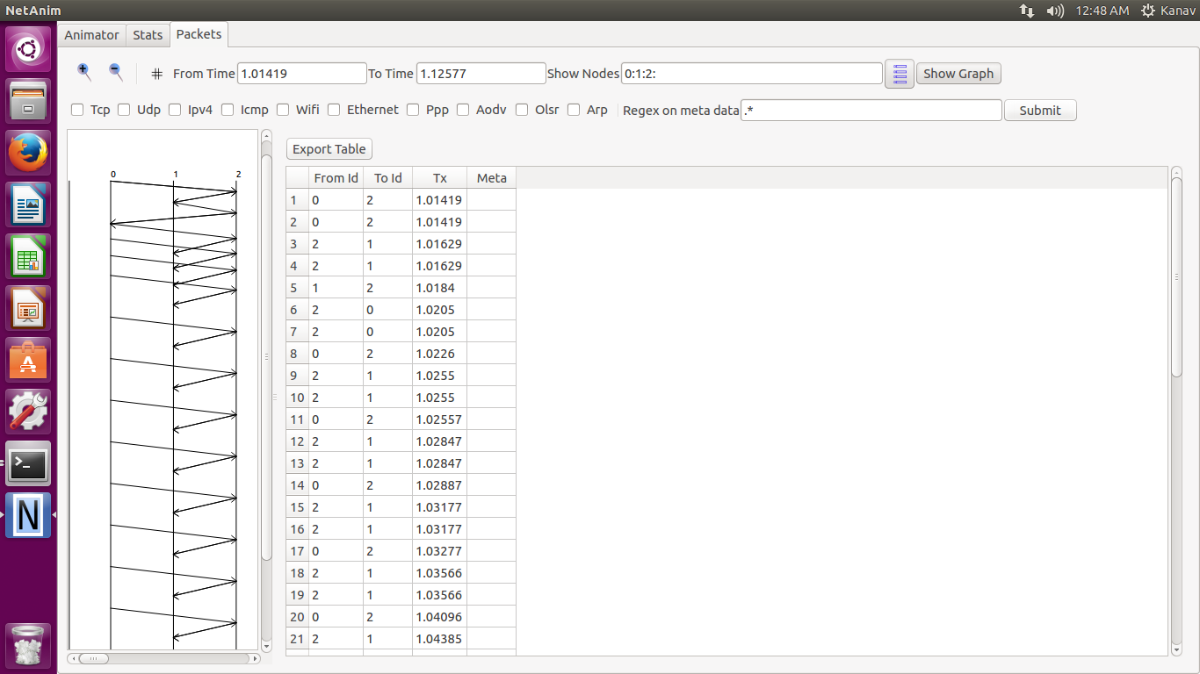

**2 to 1 Flow**

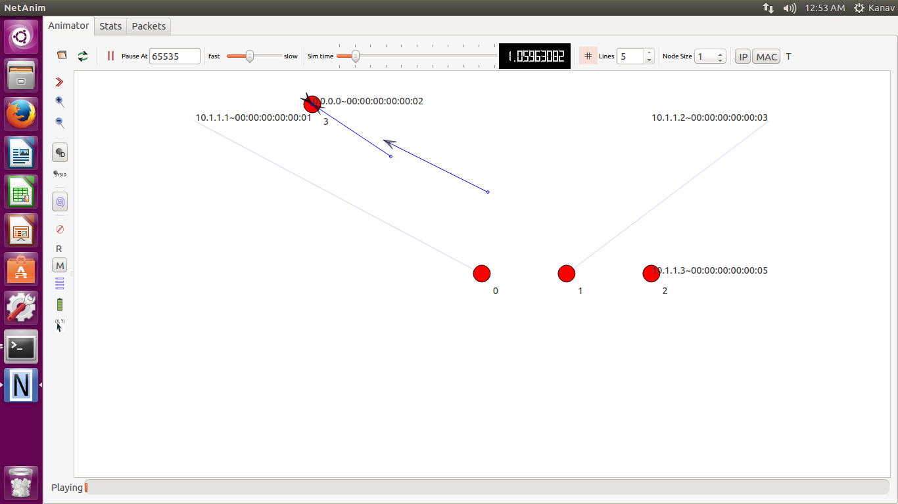

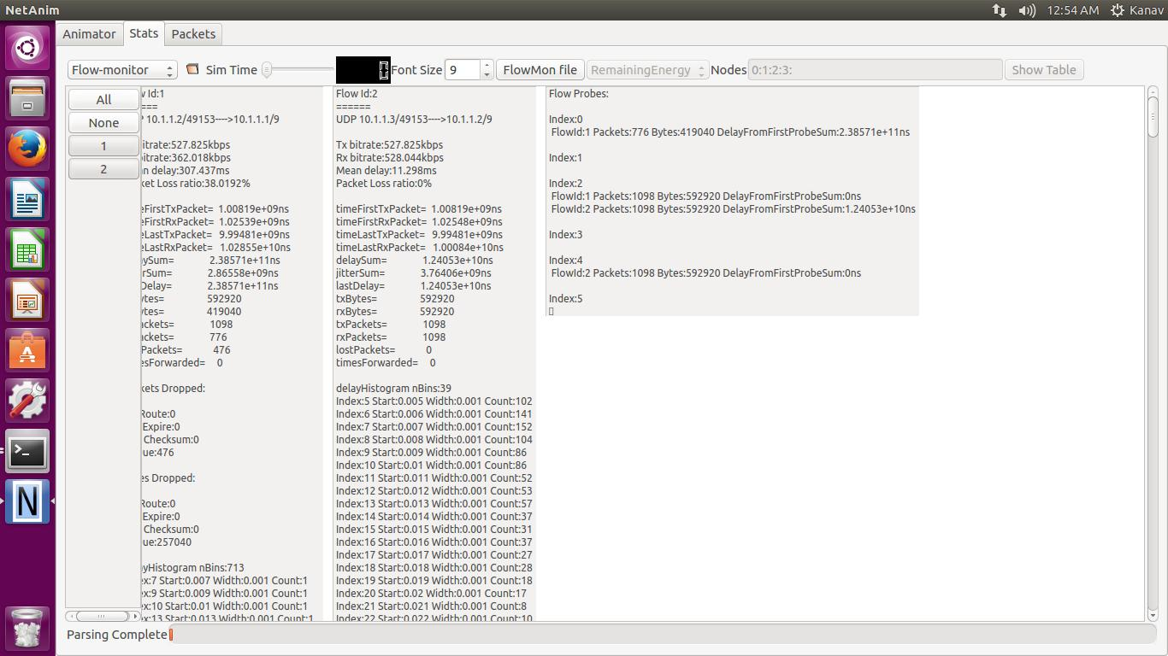

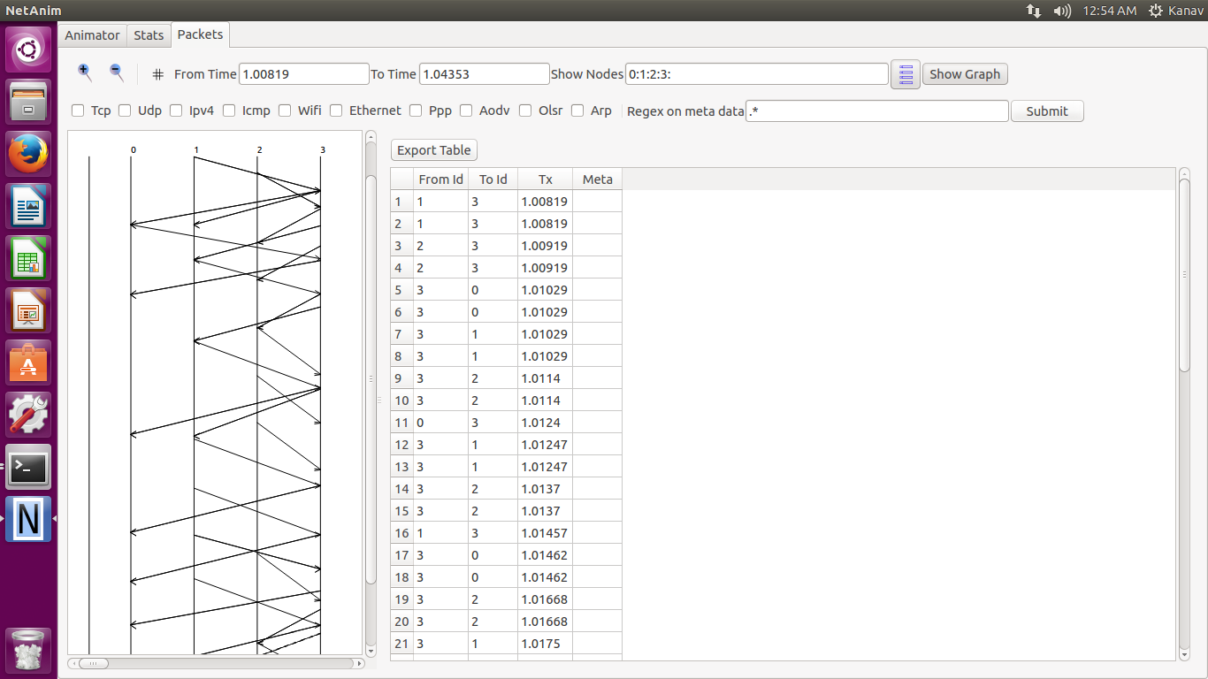

**3 to 1 Flow**

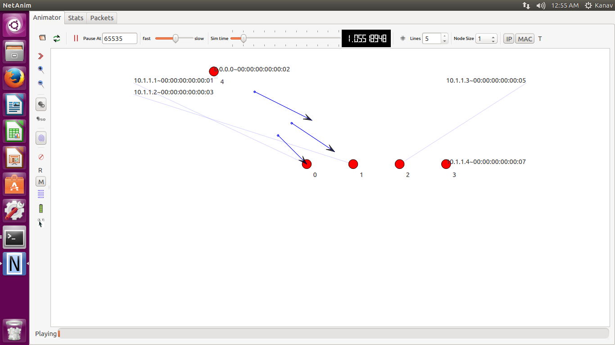

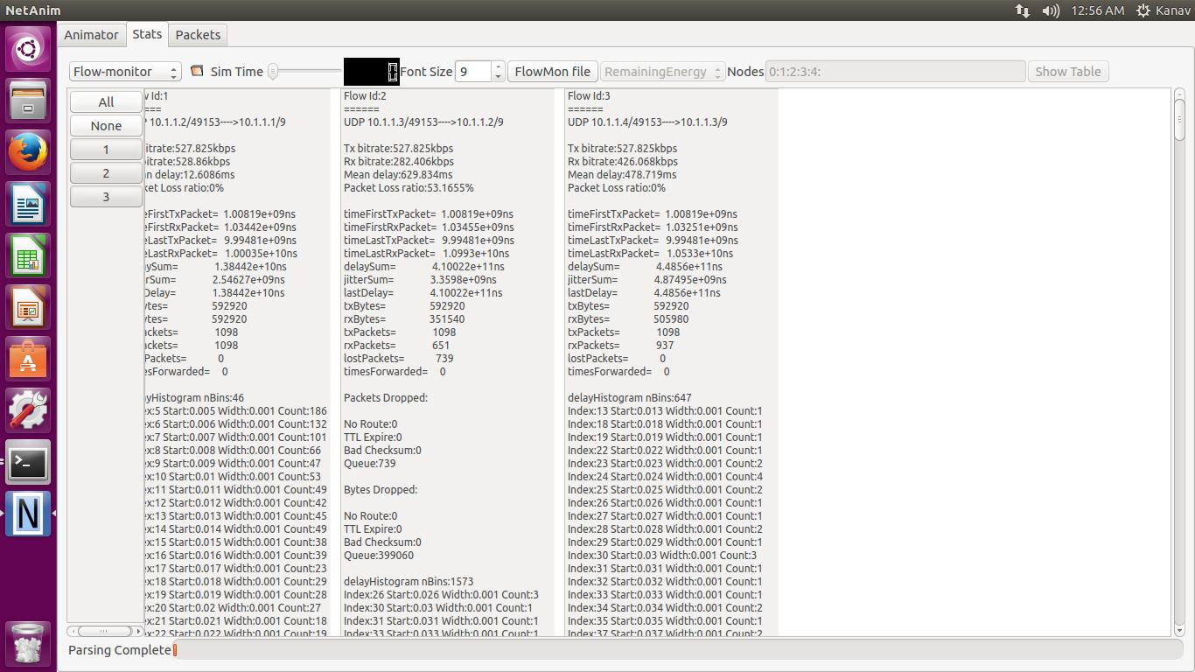

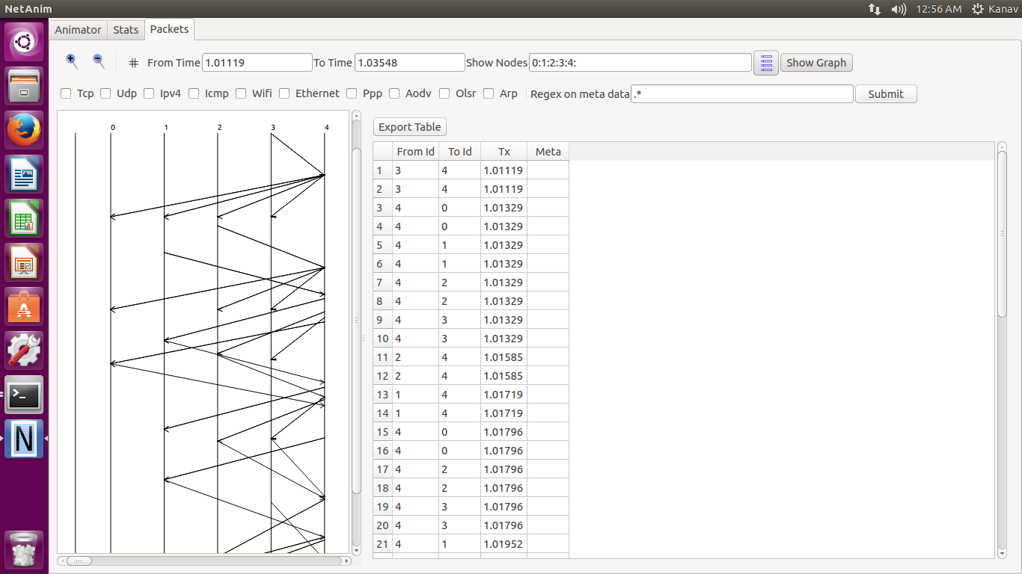

**4 to 1 Flow**

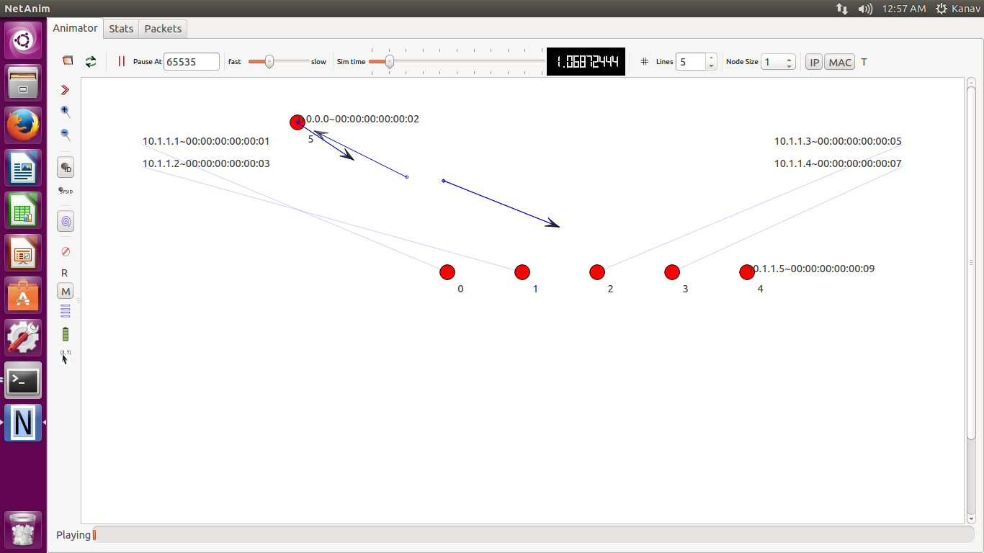

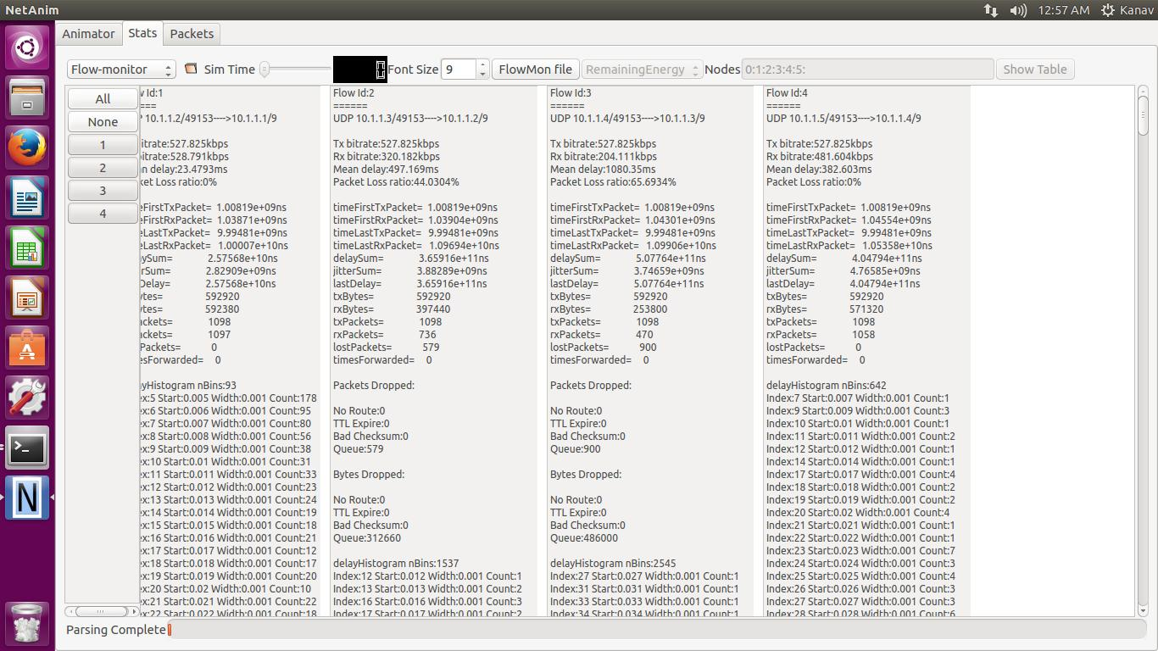

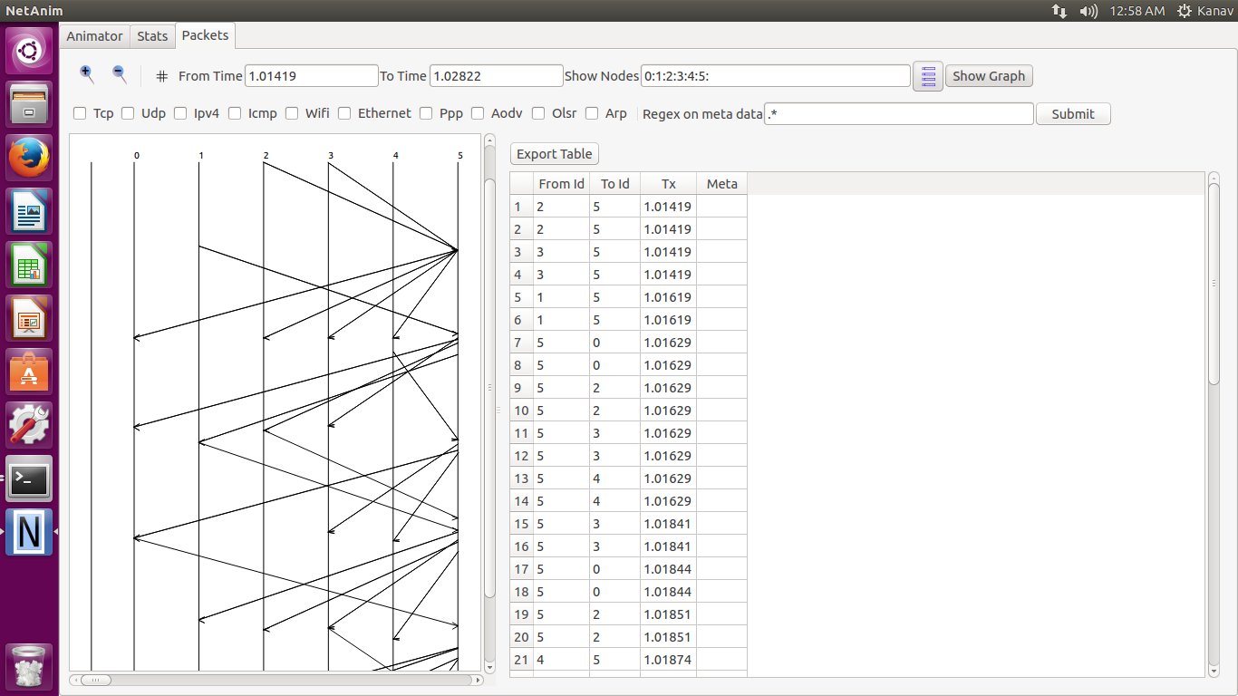

**6 to 1 Flow**

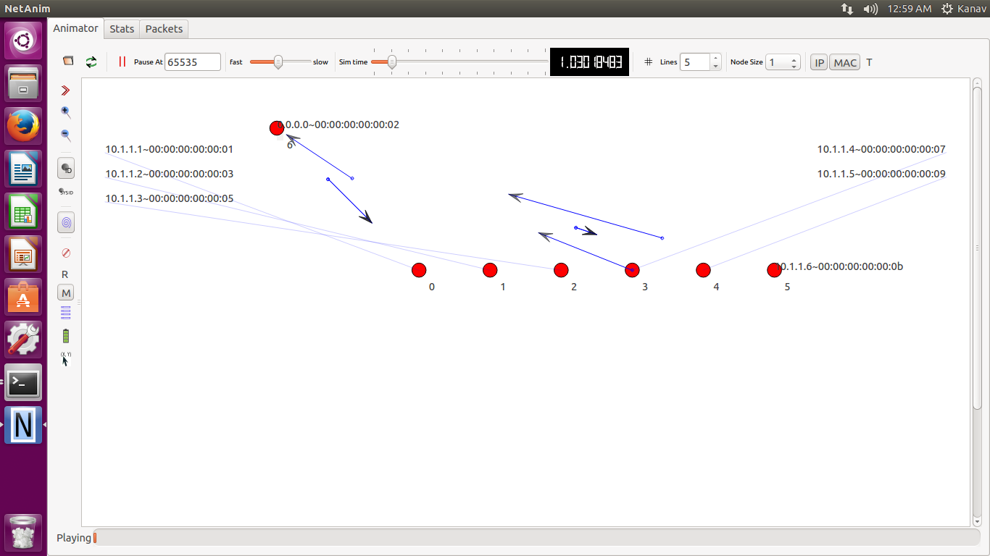

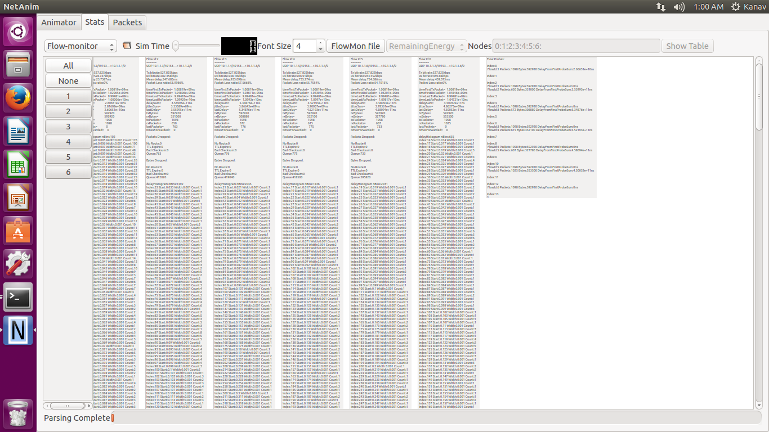

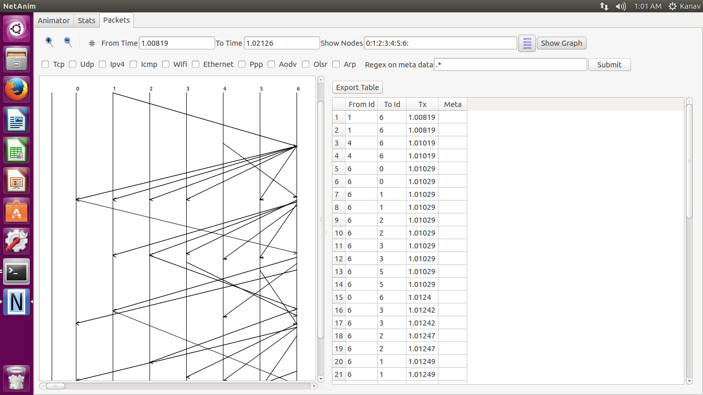

**7 to 1 Flow**

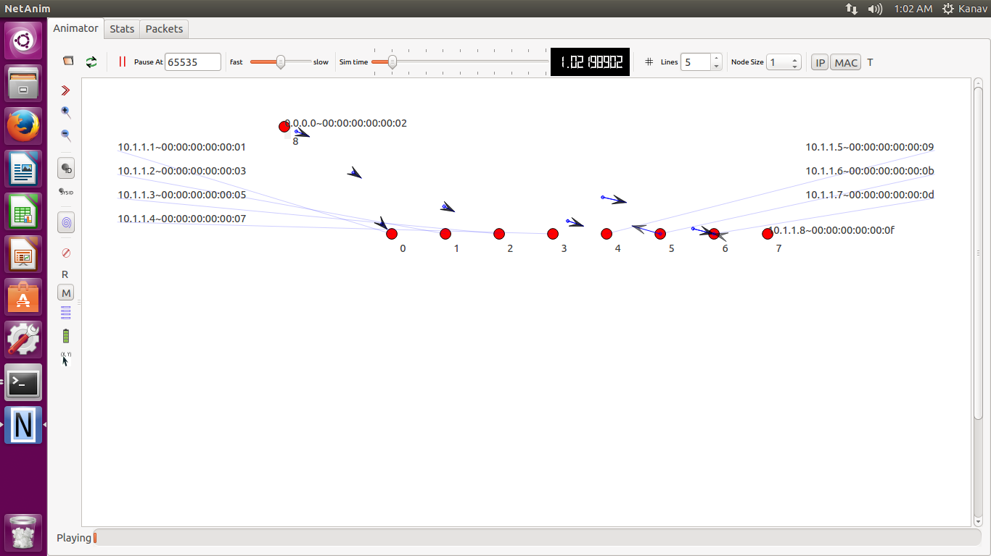

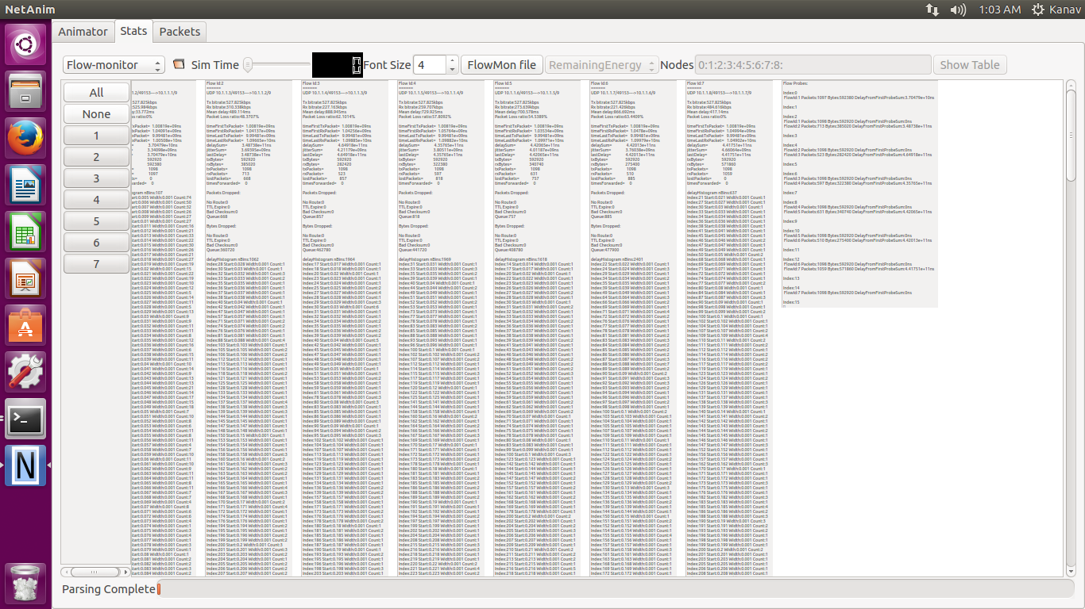

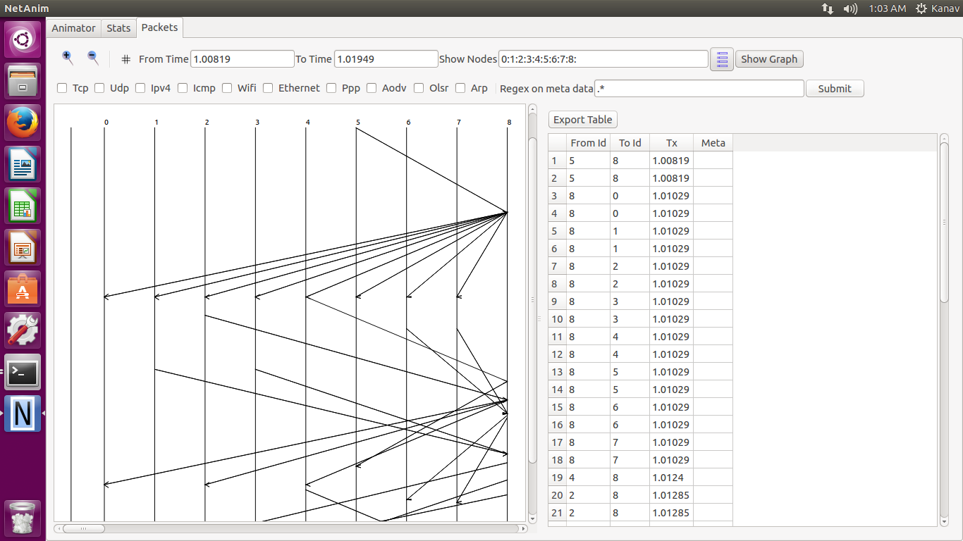

**8 to 1 Flow**

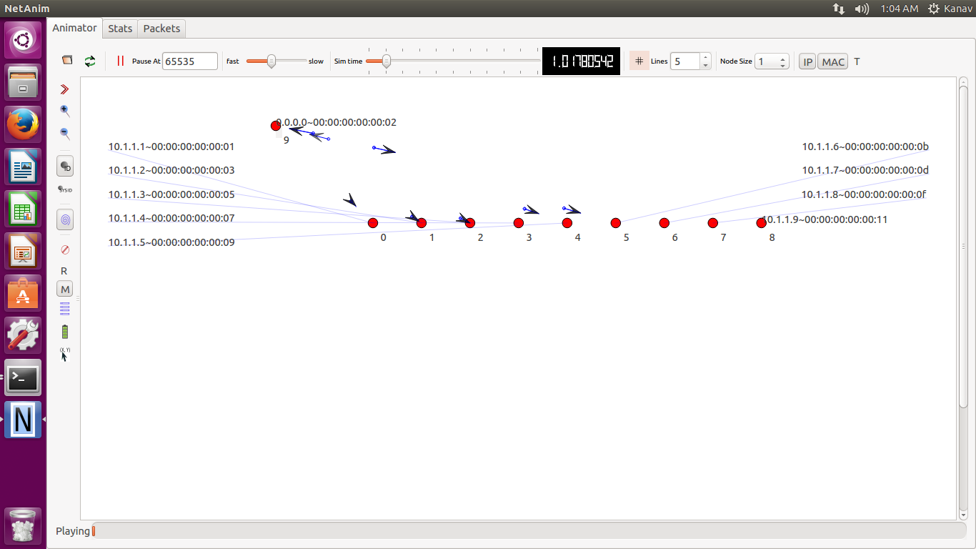

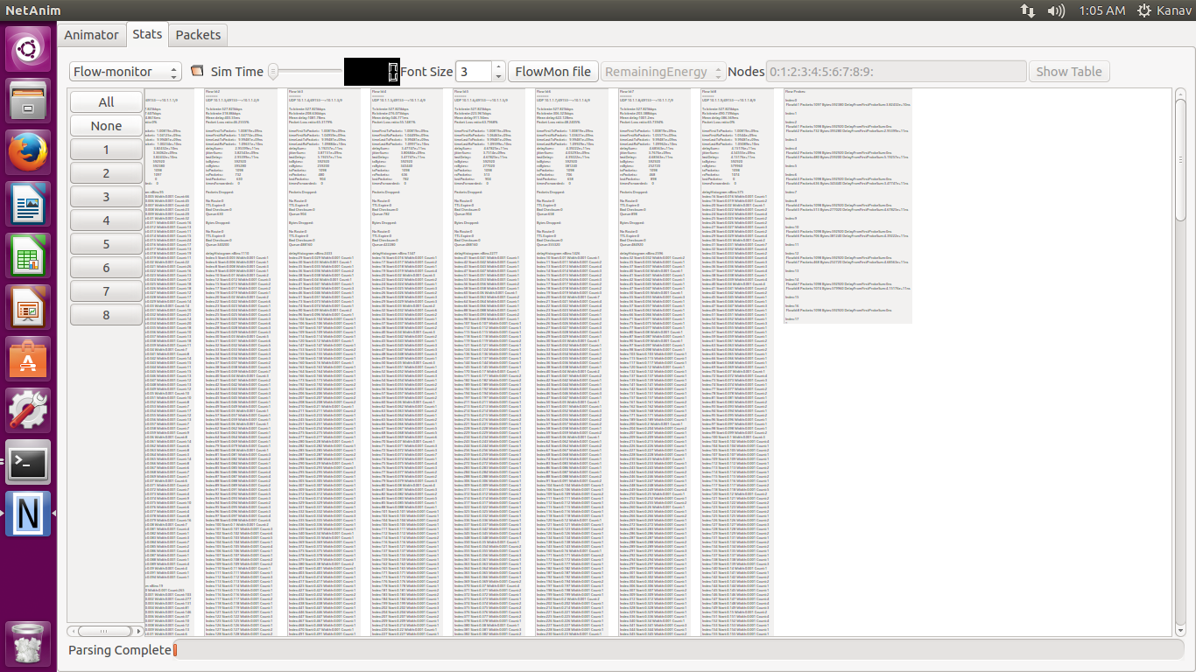

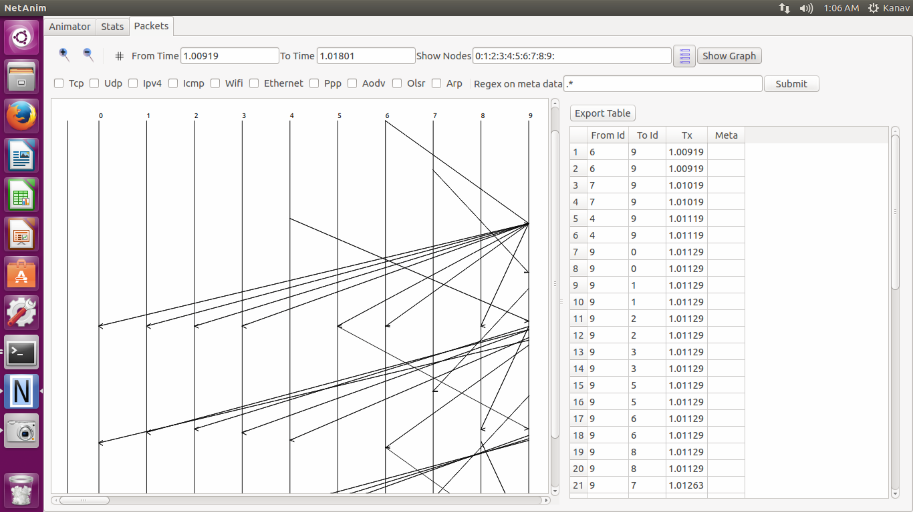

**9 to 1 Flow**

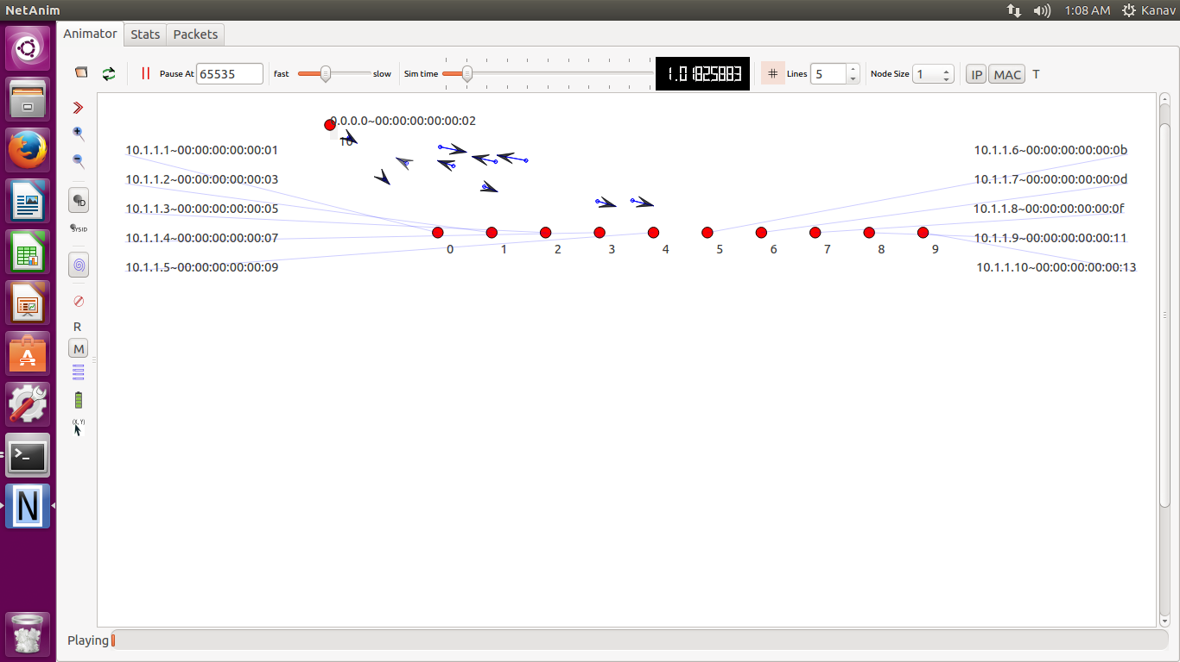

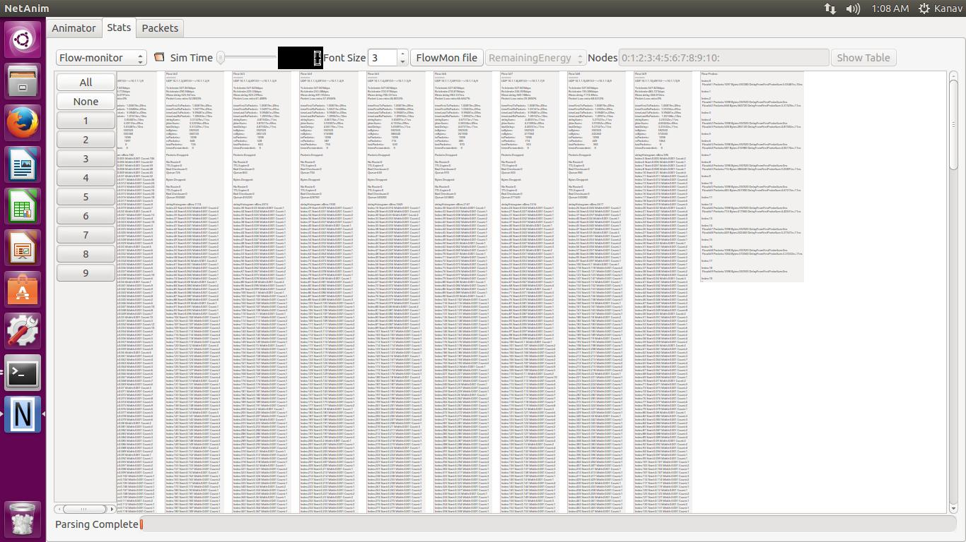

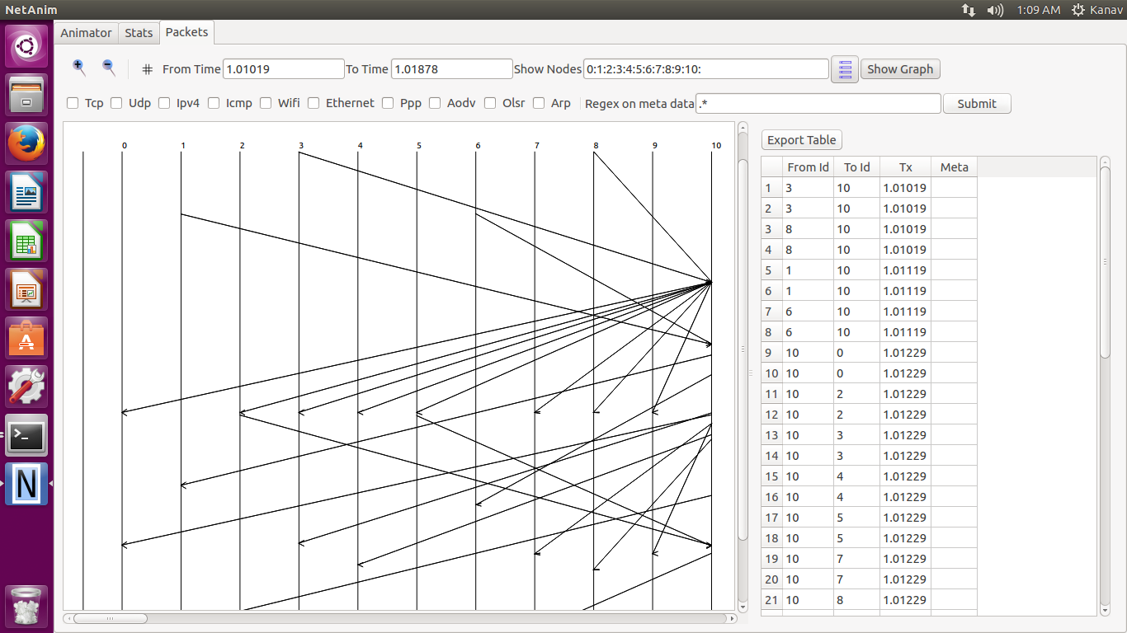

**10 to 1 Flow**

